Exclusions

and Exceptions

This course describes creating and managing issue exceptions, configuring rules, and fine-tuning security settings to ensure robust cybersecurity practices in Cortex®.

Course Objectives
After completing this course, you should be able to:

- Create exclusions to suppress issues to reduce noise
- Create exceptions that disable protection modules
- Create and manage exceptions profiles
- Differentiate between exceptions and exclusions
- Differentiate between exceptions profiles and global exceptions

Lesson Topics
We recommend that you take the lessons in numerical order, but you can use the menu for quick access to any lesson at any time.
Click the lesson title buttons to go to each lesson. You can also navigate the course using the navigation arrows below or the menu bar at the top left of the screen.
Lesson 1: Issue Exclusions
Lesson 2: Exceptions and Exceptions Profiles
Lesson 3: Issue Exceptions
Lesson 4: Global Exceptions

Issue

Exclusions​

This lesson describes the configuration of exceptions in Cortex. It covers how to view, create, and manage issue exclusions, rule suppressions, and disabled rules. Additionally, it explains the differences between issue exclusion actions and exclusion rules.

Exceptions Configuration
To view new and existing exception rules, navigate to Settings > Exceptions Configuration.
You can view and create exclusions and rule suppressions as well as disable rules in a single pane.
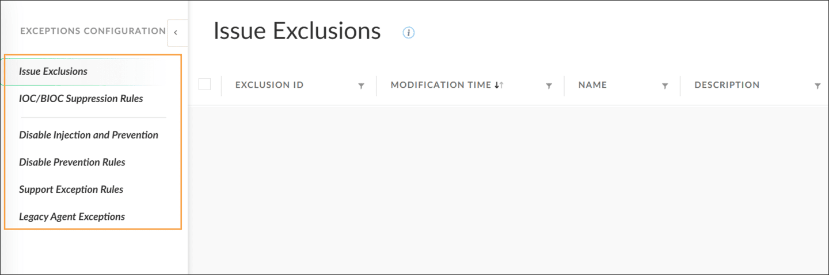

Issue Exclusion Rules
An issue exclusion rule is a rule to suppress issues in Cortex.
You can create issue exclusions in the Issues view by selecting Manage Issue > Exclude Issue in the right-click shortcut menu of an issue, or by creating an issue exclusion rule. The shortcut menu option is an individual exclusion and will not show up as a rule. It will only affect the issue which was originally right-clicked for exclusion.
Click the image to enlarge it.
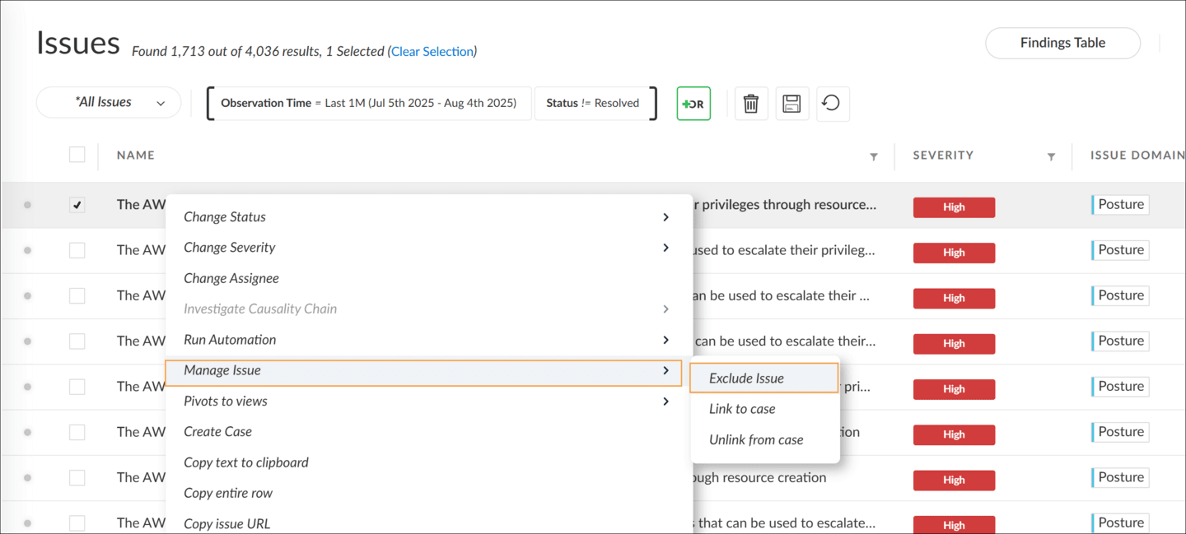

Demo: Creating New Exclusion Rules
Watch this demonstration to see how to create new exclusion rules.
Elapsed time
0:00/
Total
1:31

Cases and Excluded Issues
A case’s status is affected by excluding issues associated with that case.
If 100 percent of a case's remaining issues are excluded, the case’s status will automatically change to Resolved. Cortex will continue to group issues into an Auto-Resolved case for up to six hours. In the situation where an issue is triggered during this duration, Cortex will re-open the case.
Any update made to an issue impacts the associated case.
If less than 100 percent of a case’s remaining issues are excluded, the case’s status will not automatically change.
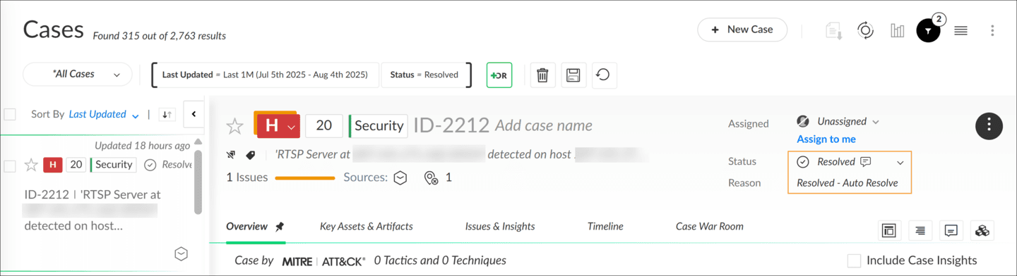

Exclude Issue Action versus Creating an Exclusion Rule
Understanding the difference between excluding an issue action and creating an exclusion rule is essential for effective issue management.
Here's a breakdown of the differences:
- 
- Creation Process
- Individual issue exclusions are used to exclude specific issues, typically accomplished via a right-click action. On the other hand, exclusion rules are broader and designed to exclude a set of related issues.
- 
- Visibility
- Exclusion rules are recorded and can be found in the Issue Exclusions table located at Settings > Exceptions Configurations > Issue Exclusions. In contrast, individual issue exclusions do not appear in this table.
- 
- Use Case Example
- When un-quarantining a file, an exclusion rule is created to exclude related issues, ensuring a comprehensive approach. This is different from using an individual issue exclusion action, which only targets a specific issue and does not automatically cover related issues.

Exclusion Optimization
To maximize the utility and security of exclusions, it is important to establish best practices for exclusion creation and management.
The following are some essential best practices when using exclusions.

Review Exclusions
Periodically review and assess existing exclusions to identify overly broad exclusions and inconsistencies between exclusion rules.

Scope Exclusions
When creating exclusions, avoid overscoping to optimize threat management.

Audit Exclusions
Audit existing exclusion collections and evaluate that your exclusion strategy aligns with your security needs.

Consolidate Exclusions
Evaluate where and how you can consolidate overlapping exclusions or when it is appropriate to transition exclusions into correlation rules for improved threat management.

​Exceptions and

Exceptions Profiles​

This lesson describes the differences between issue exceptions and issue exclusions, focusing on how each action impacts the generation and management of issues in Cortex. It also covers the various types of exceptions and their specific use cases, providing a comprehensive understanding of fine-tuning security settings.

Issue Exceptions versus Issue Exclusions
The differences between an exclusion and an exception are commonly confused.

Exclusion
An exclusion silences issues from appearing in the Cortex console but the modules continue to provide protection. While the protection exists, issues are no longer generated from it. Exclusions are used to tune out noisy false positives.

Exception
An exception disables the underlying protection entirely. Thus, issues aren’t being generated because the protection is removed. Exceptions are used to prevent conflicts between Cortex and applications, leaving the endpoint vulnerable to attacks of this type.
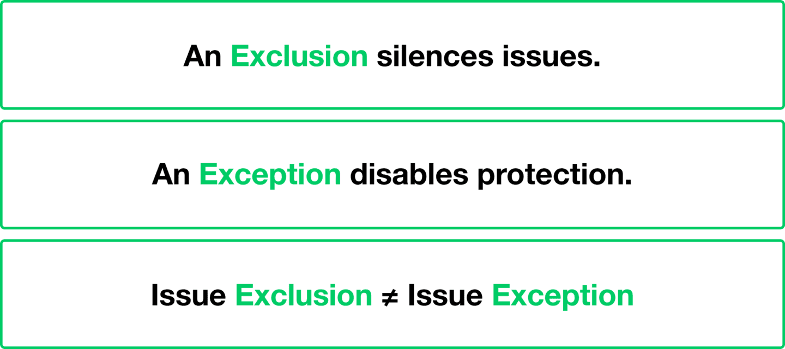

Exceptions Profiles
In the Cortex management console, exception profiles allow for the customization of security settings on endpoints by creating specific exceptions.
Exceptions in the Cortex management console are settings that disable certain protections. By using these exceptions, you can fine-tune security measures to resolve issues such as incompatibilities, crashes, and false positives. For instance, you might need to disable Child Process Protection for a particular process if it crashes due to compatibility issues.
There are various types of exceptions available, depending on which protection feature you want to disable, such as Process Exceptions and Support Exceptions. Exception profiles can be created for devices running Windows, macOS, and Linux, providing flexibility across different operating systems.
After creating exceptions, you can associate them with a policy rule. The image shows an exceptions profile for Windows. Click the image to enlarge it.
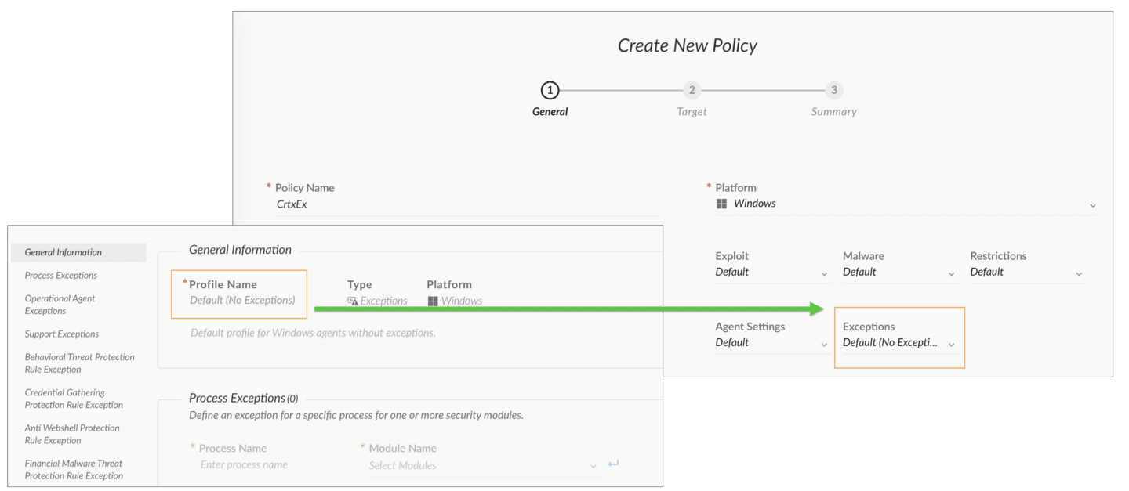

​Exception Types​
Exceptions can only disable protections, not enable them. There are various types of exceptions.
Here are a few types of exceptions.

Process Exception

The process exception disables selected exploit and malware protection modules on a process to allow a file to run.

Support Exception

Support exceptions are created by the Palo Alto Networks support team to temporarily address policy issues for a specific customer.

Behavioral Threat Protection (BTP) Rule Exception

A BTP rule exception disables a specific BTP rule to allow a process to keep running.

Local Analysis Rules Exception

A local analysis rules exception disables all the local analysis rules that are involved in creation of a specific issue.

Advanced Analysis Exception

An advanced analysis exception can be created by the cloud-based dump analysis service after analysis of a memory dump file.

Digital Signer Exception

A digital signer exception removes an untrusted signer from the block list to allow files signed by this signer to be able to run.

Network Packet Inspection Engine Exception

A network packet inspection engine exception disables a network packet Inspection rule that is involved in creation of a specific issue.

Credential Gathering Protection Rule Exception

A credential gathering protection rule exception disables a specific credential gathering protection rule across all processes.

Anti-Webshell Protection Rule Exception

An anti-webshell protection rule exception disables a specific anti-webshell protection rule across all processes.

Financial Malware Threat Protection Rule Exception

A financial malware threat protection rule exception disables a specific financial malware threat protection rule across all processes.

In-Process Shellcode Protection Rule Exception

An in-process shellcode protection rule exception disables a specific in-process shellcode protection rule across all processes.

Malicious Device Prevention

A malicious device prevention rule exception protects against connecting potentially malicious devices to the endpoint.

Process Exceptions
You can create a process exception to disable selected Exploit Protection Modules (EPMs) and Malware Protection Modules (MPMs) on processes.
To create a process exception, navigate to Settings > Exceptions Configuration > Legacy Agent Exceptions. Then, click Add Rule, name the rule, select a platform, and choose Exceptions > Process Exceptions.
You can check the Select all box to disable all EPMs and MPMs. To disable only all the EPMs, check the Disable Injection box.
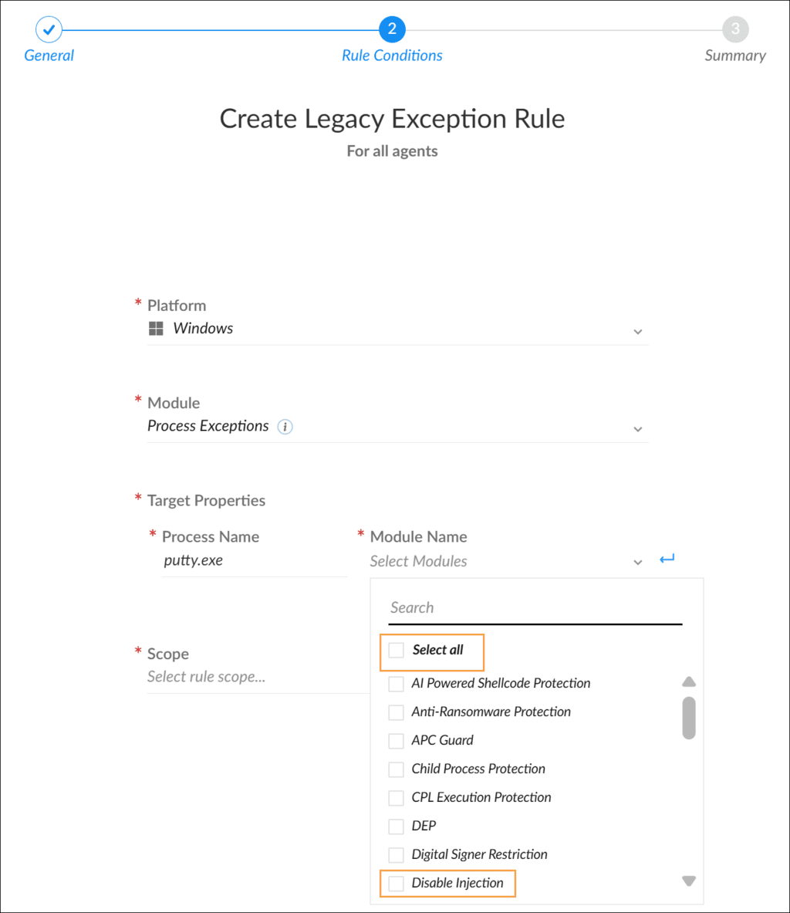

​Support Exceptions​
Support exceptions are created for a particular customer by the support team to override the default settings of protection modules.
Support exceptions are not directly created from the Cortex console. Instead, they are available as a tool for the Palo Alto Networks support team to resolve temporary amendments or to make changes to specific security settings.
Palo Alto Networks can issue support exceptions that change the default configuration of an internal module and other applied security settings. To deliver a support exception, the Palo Alto Networks support team can provide a JavaScript Object Notation (JSON) file containing the configuration changes or amendments to your security configuration.
After you receive the support exception file, you will manually import it to Cortex. You should delete or disable any exceptions you created earlier that may conflict with a support exception. Otherwise, the support exception may be shadowed by other exceptions because administrator-defined exceptions usually take precedence over support exceptions.
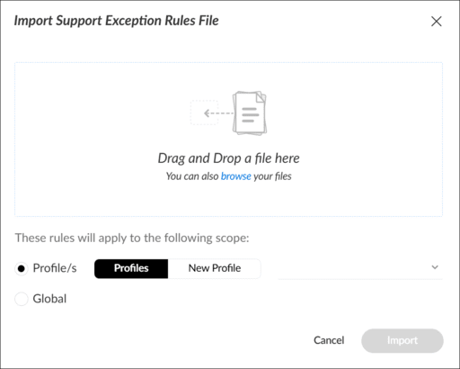

Other Exception Types
Because add or create actions are not available for other exception types, these types cannot be added directly from the profile.
The following describes how exceptions are created for other alert types:
- 
- Malware Issues
- For malware issues, create exceptions directly from an issue's shortcut menu.
- 
- Exploit Issues
- For exploit issues, an advanced analysis exception is automatically created if you enable Advanced Analysis.
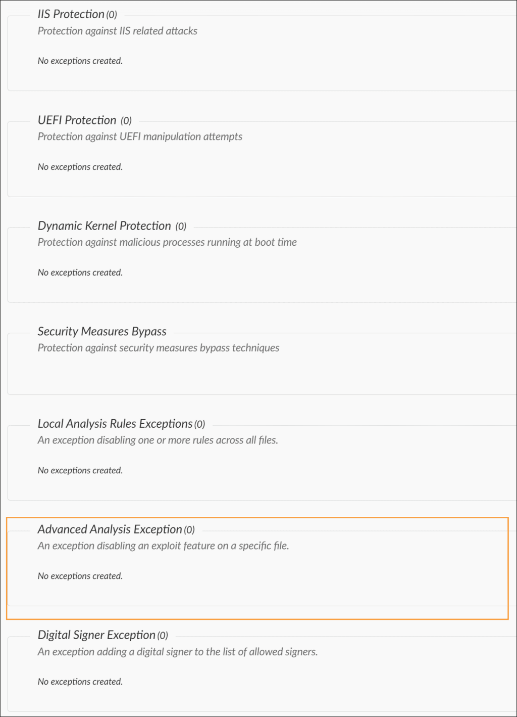

​Advanced Analysis​
Advanced analysis refers to the automated process of analyzing memory dumps in the cloud. This feature allows Cortex instances to automatically retrieve, upload, and analyze memory dumps through a cloud-based dump analysis service. The results, or verdicts, from this analysis provide crucial insights into potential threats.

Dump Analysis Verdict
The verdict from a dump analysis can be one of three types: malware, benign, or inconclusive. Malware indicates a confirmed threat. Benign suggests that the prevention is likely a false positive. And, inconclusive requires further investigation by the research team.
If the verdict is benign, an Advanced Analysis exception is created. This exception disables the Endpoint Protection Manager (EPM) that terminated the process.
The graphic shows the exploit prevention flow of XDR agents. Click the image to enlarge it.
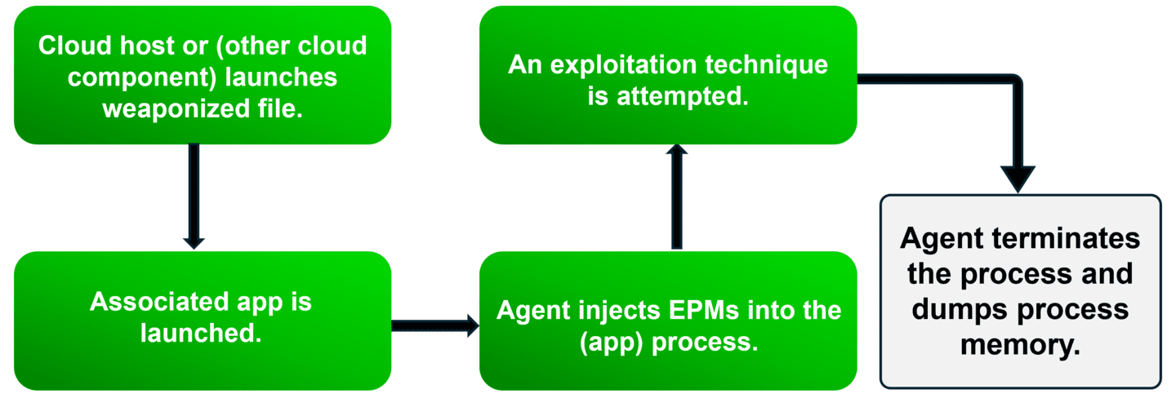

Configuring Advanced Analysis Settings
To utilize Advanced Analysis, you must enable the settings in two different areas. Click the images to enlarge them.

Global Settings
Navigate to Settings > Configurations > General > Agent Configuration.
These settings allow Cortex XDR instances to connect to the cloud-based dump analysis service.
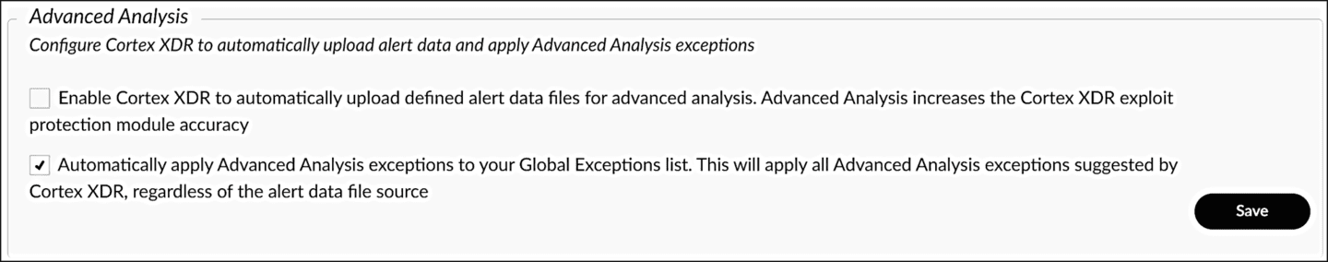

Agent Settings Profile
In this profile, you specify the size of memory dump files. Configure the automatic upload of dump files from agents to Cortex instances.
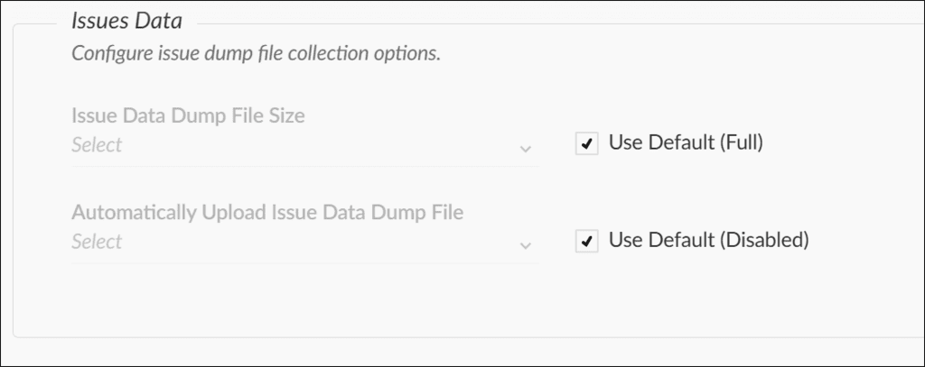

Issue

Exceptions​

This lesson describes creating issue exceptions to streamline issue management for robust cybersecurity. It explains the process of creating and managing issue exceptions, the types available, and the distinction between issue exceptions and issue exclusions.

Creating Issue Exceptions
Efficiently managing issues is crucial for robust cybersecurity, and you can streamline this process by creating issue exceptions.
To create an issue exception, right-click on the issue and select Manage Issue > Create issue exception from the shortcut menu. If you accidentally exclude an issue, simply right-click on it again and select Manage Issue > Undo issue exception.
Note: Creating issue exceptions is only available for certain issue types. For example, you can't create an exception for WildFire Malware issues, but you can add the file to the allow list instead.
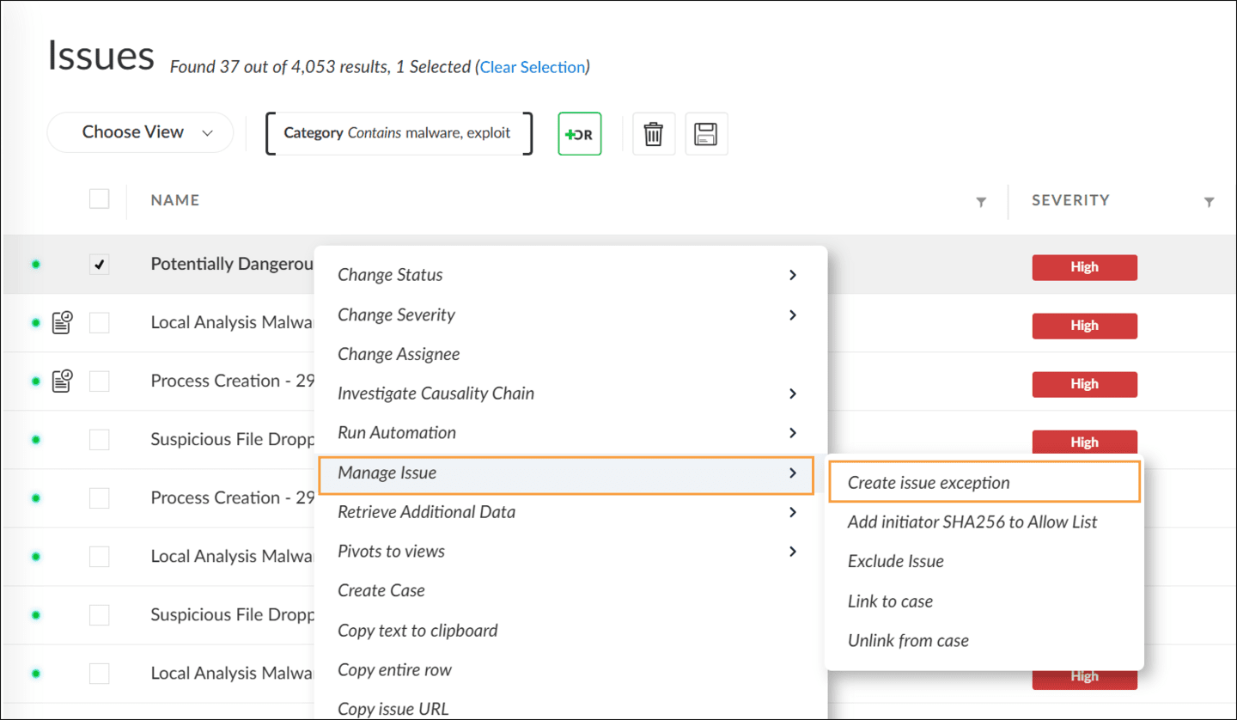

​Exception Types​
Exception types are created when you perform the Create issue exception action.

Issue Table Information
The Issues table displays the issue name, indicating which type of exception will be made. Additional information displayed includes the platform, generating issue identification (ID), rule name, and signers issue data.
Click the image to enlarge it.
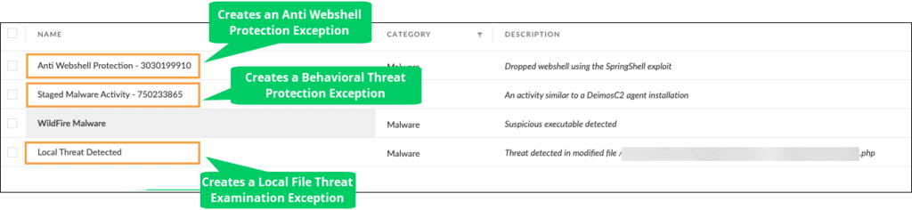

Viewing Your Profile Exceptions
To view your profile exceptions, navigate to Inventory > Endpoints > Policy Management > Prevention > Profiles. In the Profiles table, locate the operating system (OS) for which you created your global or profile exception. Right-click to view or edit the exception properties.

Click the image to enlarge it.
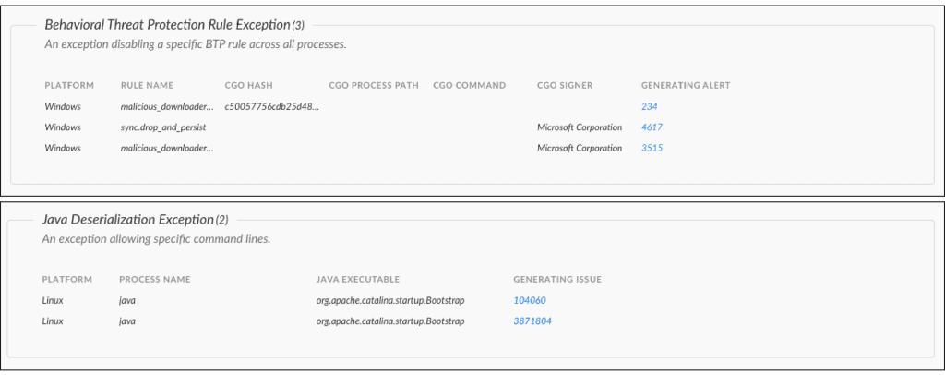

Issue Exception versus Exclude Issue
There are ways to distinguish between an issue exception and an excluded issue. While both actions result in the absence of a specific issue in the Issues table, their implementations differ.
Here are the main differences:

Issue Exceptions

Issue exceptions are implemented by the Cortex XDR agent. When you create an issue exception, Cortex sends a command to the agent to stop generating any issue of this type. This means the agent itself no longer produces these specific issues.

Exclude Issue

In contrast, issue exclusions do not involve the Cortex XDR agent. The agent continues to create and send issues of this type, but Cortex disregards them in the management console. Essentially, issue exclusions filter out these issues at the management console level without stopping their generation at the agent level.

Results of Both Actions

Both issue exceptions and excluded issue result in the same outcome: you won’t see these issues in the Issues table within the management console.
Note the action names in the issue shortcut menu.
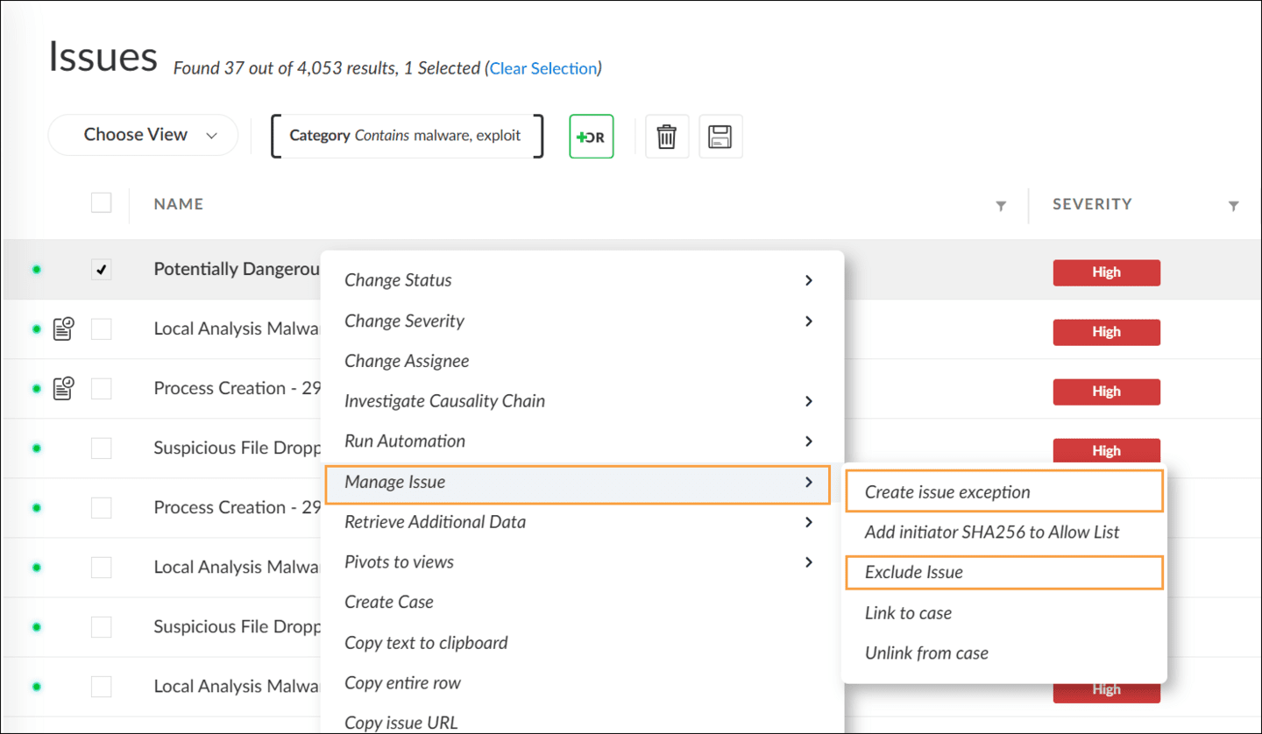
You can use the Query Builder to search for data related to issues that have been excluded. This tool allows you to locate and review data even if the issues are not shown in the Issues table.



Global

Exceptions

This lesson describes the process of creating issues exceptions to efficiently manage cybersecurity issues. It covers how to create, view, and edit exceptions, the types of exceptions available, and the differences between issue exceptions and issue exclusions.

Global Exceptions Applications
Global exceptions are a powerful tool for managing issues and policies across all endpoints. Global exceptions unconditionally apply to all endpoints. This means that once a global exception is set, it affects every endpoint without the need for specific policy rules. These exceptions offer a way to fine-tune settings across all endpoints.
Click the images to enlarge them.

Global Exception Management
Cortex enables you to manage the Global Endpoint Policy exceptions from a central location and easily apply them across multiple profiles.
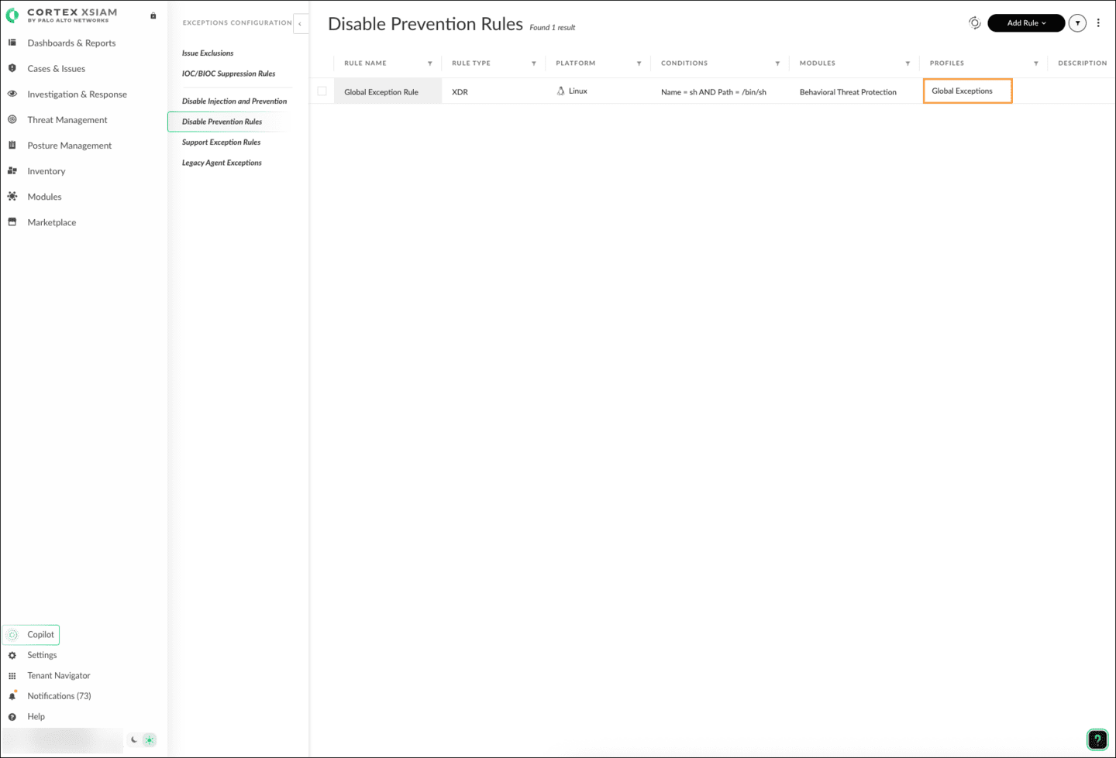

Creating Global Exceptions
Go to Settings > Exception Configurations to find the Disable Prevention Rules menu.
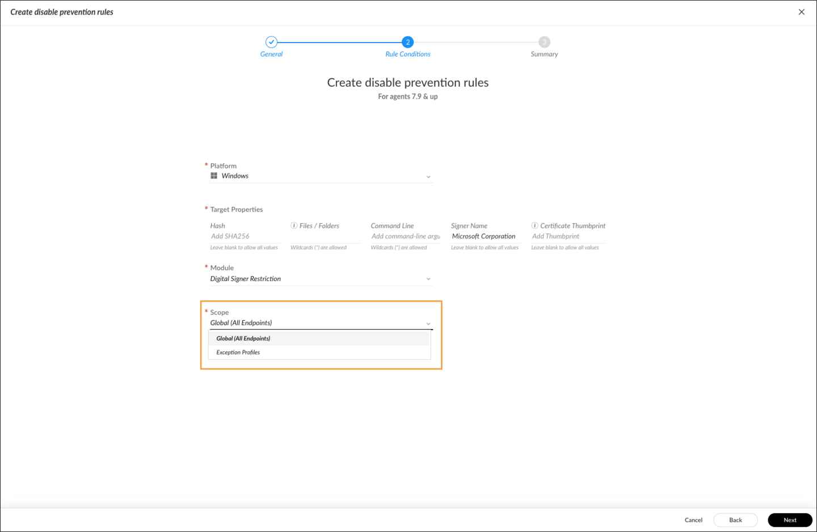

Applying Exceptions by Policy Rules
Alternatively, you can navigate to Inventory > Endpoints > Policy Management > Prevention > Profiles and select an Exceptions profile to apply exceptions to specific endpoints based on policy rules. These exceptions are determined by the policies assigned to those endpoints, providing more granular control.
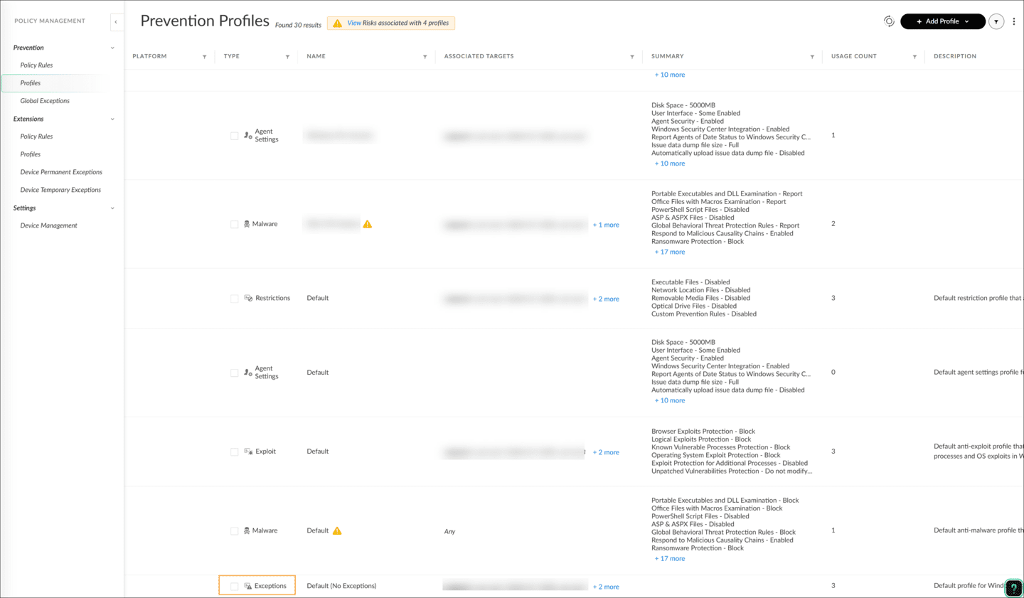

Aggregation of Exceptions
Both global exceptions and exceptions in profiles contribute to the total set of exceptions applied to endpoints. This aggregation ensures that all exceptions are considered, whether they are applied globally or through specific policy rules.

Course Summary
Now that you've completed this course, you should be able to:

- Create exclusions to suppress issues to reduce noise
- Create exceptions that disable protection modules
- Create and manage exceptions profiles
- Differentiate between exceptions and exclusions
- Differentiate between exceptions profiles and global exceptions

